Risk Assessment Form
This form should be completed with a list of hazards that affect the session, and should be written from a coaching perspective, not a venue management perspective. For each risk assessment there should be associated Emergency Action plan to be used in case a risk occurs.

Venue: |  | ARDINGLY COLLEGE POOL | Venue Contact Name & Contact Details: | Clare Kapff  Clare.Kapff@ardingly.com  venuehire@ardingly.com  Direct: 01444 893152  Office: 0144489303
Address:  (Include postcode) |  | THE SWIMMING POOL  ARDINGLY COLLEGE  COLLEGE ROAD  ARDINGLY  RH17 6SQ
Group: |  | MID SUSSEX TRIATHLON CLUB | Location of first-aider: | LIFE GUARD ON DUTY
Date: |  | EVERY TUESDAY EVENING | Location of Defibrillator | POOLSIDE
Time: |  | 8.00 – 9.00PM | Location of telephone: | POOLSIDE OFFICE  (9 FOR OUTSIDE LINE)
Participants: | Number: | 8-24 | Location of toilets: | CHANGING ROOMS
 | Age: | ADULTS (18-65) | Location of changing rooms: | DOORS TO LEFT OF CORRIDOR FROM MAIN ENTRANCE
 | Ability: | MIXED. NOVICE TRIATHLETES TO EXPERIENCED AGE-GROUP TRIATHLETES  1 PARATRIATHLETE | Location of first-aid kit: | POOLSIDE OFFICE
Lead coach name: |  | Steve McMenamin | Stocked and maintained: | ☒ Yes ☐ No
Venue documents read and understood  (please ✔ appropriate box): |  | Normal operating procedures:  ☒ Yes ☐ No | Additional notes: | MOBILE PHONE SIGNAL IS VERY POOR ON SITE GENERALLY AND SHOULD THEREFORE NOT BE RELIED UPON
 |  | Health and safety policy:  ☒ Yes ☐ No | DIAL 9-999 IN EMERGENCY FROM OFFICE PHONE
Emergency action plan (EAP):
☒ Yes ☐ No

Name of person conducting risk assessment: | Signed: | Date:
Steve McMenamin |  | 06/01/2022

Risk Assessment Form

Location & Description of Hazard: | People at Risk: | Level of Risk (High/Medium/Low): | Advice Required: (from whom) | Action(s) to Mitigate/ Remove Risk: | Person responsible for resolution: | Residual Risk: After resolution | Dates Reviewed
POOLSIDE:  • LIGHTING – GOOD LIGHTING LEVELS, NO GLARE  • NOISE – ACOUSTICS ARE CHALLENGING  • 25M POOL –  VISIBILITY IS NOT AN ISSUE  • SLIPPERY SURFACE WHEN WET  • PLANT ROOM – CHEMICALS, RISK OF CHLORINE GAS | SWIMMERS / COACHES / SPECTATORS | Likelihood:  MEDIUM  Impact:  MEDIUM | X No  • Yes  If yes, who: | • ENSURE ALL LIGHTS ARE ON FOR SESSION  • ENSURE SWIMMERS ARE INSTRUCTED NOT TO RUN AROUND POOLSIDE  • ALL POOL STAFF TRAINED IN HANDLING POOL CHEMICALS | LEAD COACH /  POOL STAFF | Likelihood:  LOW  Impact:  LOW | 06/01/2022 - SMAC
WATER/POOL:  • 2M DEEP AT DEEP END SO TOUCHING THE POOL FLOOR AND STAYING ABOVE WATER IS NOT POSSIBLE  • WATER TEMPERATURE USUALLY 28º AND CAN FEEL WARM CAUSING OVERHEATING  • AIR TEMPERATURE – VENTILATION IS POOR, SO CAN BECOME VERY WARM CAUSING OVERHEATING OR DISCOMFORT  • LOW WATER QUALITY RISKING SICKNESS  • LOW WATER QUALITY AFFECTING BREATHING AND/OR VISIBILITY  • POOL TILES ARE IN GOOD CONDITION – CHECK REGULARLY FOR ANY CHANGE | SWIMMERS / COACHES SPECTATORS | Likelihood:  HIGH  Impact:  HIGH | • No  X Yes  If yes, who:  COACH TO CHECK WITH POOL STAFF FOR WATER QUALITY UPDATES | • ENSURE SIGNAGE IS IN PLACE  • BRIEF SWIMMERS ON SHALLOW & DEEP END LOCATIONS AND DEPTHS  • OPEN DOORS TO INCREASE VENTILATION WHEN REQUIRED  • LIAISE WITH POOL STAFF TO GET UPDATES ON WATER QUALITY AND POSSIBLE ISSUES  • NO DIVING AT SHALLOW END  • DIVE ONLY ON INSTRUCTION OF COACH  • ADVISE ALL SWIMMERS TO BRING PLENTY OF FLUIDS DUE TO WARM AIR & WATER TEMPERATURES | LEAD COACH / POOL STAFF | Likelihood:  LOW  Impact:  LOW | 06/01/2022 - SMAC
ORGANISATION:  • SWIMMERS NOT FOLLOWING POOL / LANE ETIQUETTE  • SWIMMERS HITTING THEIR HEAD DOING BACKSTROKE | SWIMMERS | Likelihood:  MEDIUM  Impact:  MEDIUM | X No  • Yes  If yes, who: | • BRIEFING TO INCLUDE POOL RULES & SWIM DIRECTION  • PUBLICISE LANE ETIQUETTE TO ALL MEMBERS  • COACHES TO OBSERVE ATHLETE/COACH RATIOS AS PER BRITSH TRIATHLON GUIDANCE  • ENSURE 5M FLAGS ARE IN PLACE | LEAD COACH | Likelihood:  MEDIUM  Impact:  LOW | 06/01/2022 - SMAC
PARTICIPANTS:  • UNABLE TO COMPLETE 200M FRONT CRAWL  • WELFARE CONCERNS FOR YOUTH MEMBERS  • ANY PHYSICAL OR LEARNING DISABILITIES  • UNDERLYING MEDICAL CONDITIONS, ILLNESS OR INJURY  • SWIMMERS UNABLE TO UNDERSTAND OR HEAR INSTRUCTIONS  • NUMBER OF ATHLETES IN EACH LANE | SWIMMERS / COACHES | Likelihood:  LOW  Impact:  HIGH | • No  X Yes  If yes, who:  CHECK WEEKLY WITH SWIMMERS  FOR ANY UNDERLYING MEDICAL ISSUES | • CHECK BASIC SWIM COMPETENCE OF ANY NEW SWIMMER (ENSURE MINIMUM OF 200M UNAIDED SWIMMING)  • SUITABLE LANE SUPERVISION WHEN YOUTH MEMBERS ATTEND SESSION  • ENSURE SWIMMER SIZES & ABILITIES ARE ASSESSED AND PARTICIPANTS ARE GROUPED ACCORDINGLY WITHIN SWIM LANES  • ENSURE LANE ETIQUETTE IS OBSERVED BY SWIMMERS AND MANAGED BY COACH  • ALLOW SWIMMERS TO MOVE TO SIDE / END TO REST IF FEELING FATIGUED OR UNWELL  • CHECK AT EVERY SESSION FOR ANY MEDICAL ISSUES OR INJURY – OVERT OR UNDERLYING, AND MODIFY SESSION OR EXCLUDE PARTICIPATION AS REQUIRED  • CHECK REGULARLY FOR SWIMMER UNDERSTANDING FOLLOWING INSTRUCTION  • OBSERVE LANE CAPACITY IS OBSERVED (MAX 7 SWIMMERS PER LANE) – SWIMMERS TO BE TURNED AWAY AT THE COACHES DISCRETION IF NUMBERS ARE EXCEEDED | LEAD COACH | Likelihood:  LOW  Impact:  LOW | 06/01/2022 - SMAC
POOLSIDE EQUIPMENT:  • REMOVABLE ITEMS STORED AROUND POOLSIDE INCLUDE:  STARTING BLOCKS, POOL COVER, WATER POLO GOALS, PLASTIC CHAIRS, EQUIPMENT STORAGE CRATES, SWIMMERS EQUIPMENT & DRINKS, WATER DISPENSER, OFFICE TABLE  • IMMOVABLE ITEMS AROUND POOLSIDE INCLUDE SPECTATOR BENCHES, WIPE BOARD | SWIMMERS / COACHES / SPECTATORS | Likelihood:  HIGH  Impact:  MEDIUM | X No  • Yes  If yes, who: | • ENSURE ALL MOVEABLE ITEMS NOT REQUIRED FOR THE SESSION ARE MOVED AWAY FROM POOLSIDE  • POINT OUT ITEMS TO SWIMMERS AS POTENTIAL TRIP HAZARDS | LEAD COACH / POOL STAFF | Likelihood:  LOW  Impact:  LOW | 06/01/2022 - SMAC
VENUE ACCESS:  • STEEP STEPS & INCLINED SLOPE DOWN TO POOL ENTRANCE IS POORLY LIT WHEN DARK AND CAN BE SLIPPERY IN WET/COLD WEATHER | SWIMMERS / COACHES / SPECTATORS | Likelihood:  LOW  Impact:  HIGH | X No  • Yes  If yes, who: | • MAKE ALL ATTENDEES AWARE AS APPROPRIATE | LEAD COACH / COLLEGE CONTACT | Likelihood:  LOW  Impact:  LOW | 06/01/2022 - SMAC
HUMAN RESOURCES:  • LIFE GUARD NOT IN PLACE  • SWIMMER / LIFEGUARD RATIO OF 1:40 EXCEEDED  (LANE SWIMMING)  • COACH / ATHLETE RATIO | SWIMMERS / COACHES | Likelihood:  MEDIUM  Impact:  HIGH | X No  • Yes  If yes, who: | • ENSURE LIFEGUARD IS IN PLACE PRIOR TO SESSION START  • NO LIFEGAURD – NO SESSION  • ASSESS PARTICIPANT NUMBERS AND ENSURE THEY MEET RATIOS FOR LIFEGUARD & COACHING  • ESTABLISH COACHED AND UNCOACHED LANES IF REQUIRED DUE TO RATIOS | LEAD COACH | Likelihood:  LOW  Impact:  MEDIUM | 06/01/2022 - SMAC
 |  | Likelihood:  Impact: | • No  • Yes  If yes, who: |  |  | Likelihood:  Impact:
 |  | Likelihood:  Impact: | • No  • Yes  If yes, who: |  |  | Likelihood:  Impact:
 |  | Likelihood:  Impact: | • No  • Yes  If yes, who: |  |  | Likelihood:  Impact:
 |  | Likelihood:  Impact: | • No  • Yes  If yes, who: |  |  | Likelihood:  Impact:
 |  | Likelihood:  Impact: | • No  • Yes  If yes, who: |  |  | Likelihood:  Impact:
Add more pages as required

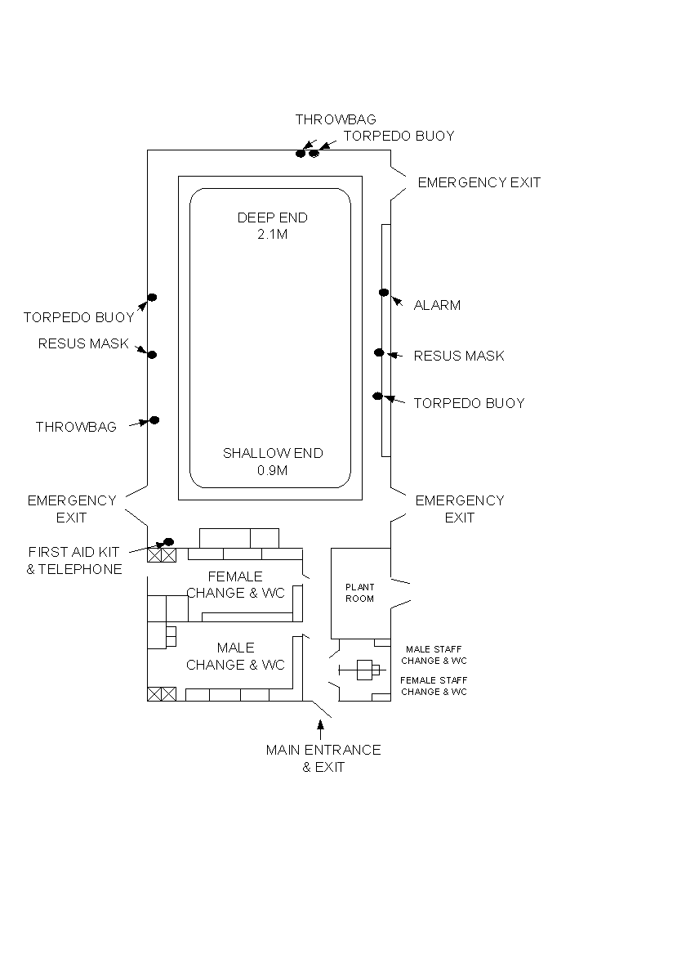
Insert Diagram(s) of layout of venue with key safety elements marked (this page is intended to be shared between Risk Assessment and EAP):

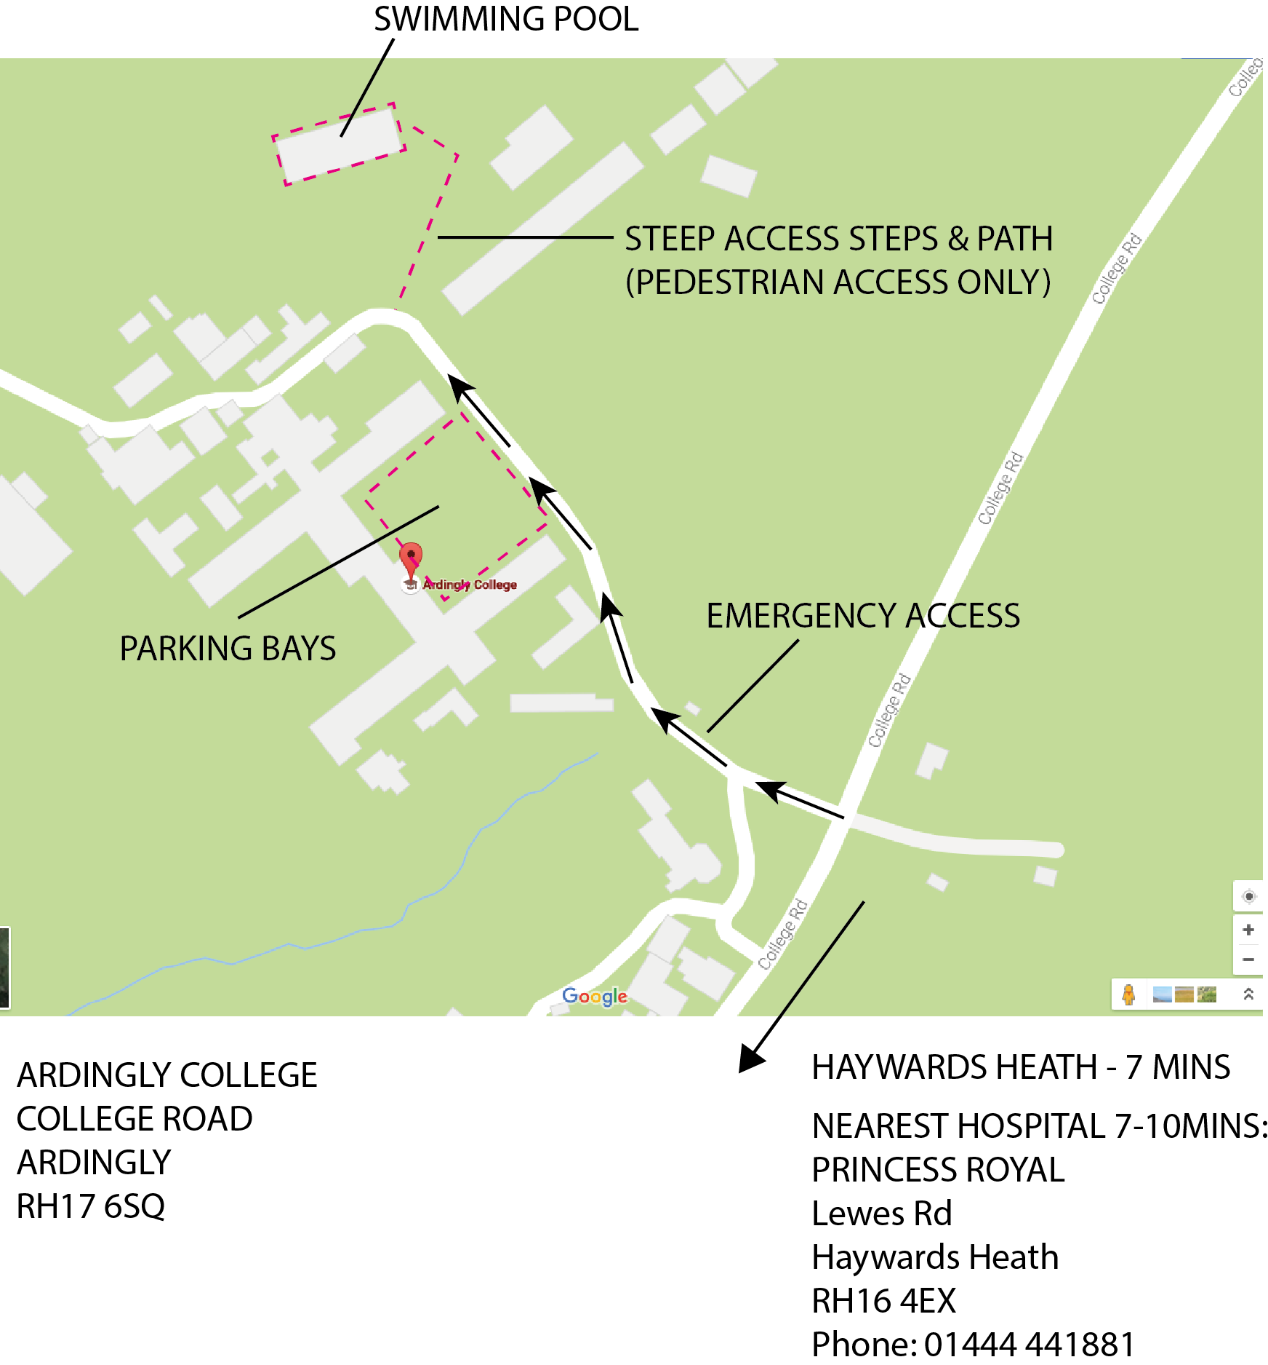 OVERALL SITE PLAN

